Introduction to Global Warming

This graph shows the increases during the last century in average global temperature and levels of carbon dioxide (CO₂) in the atmosphere.

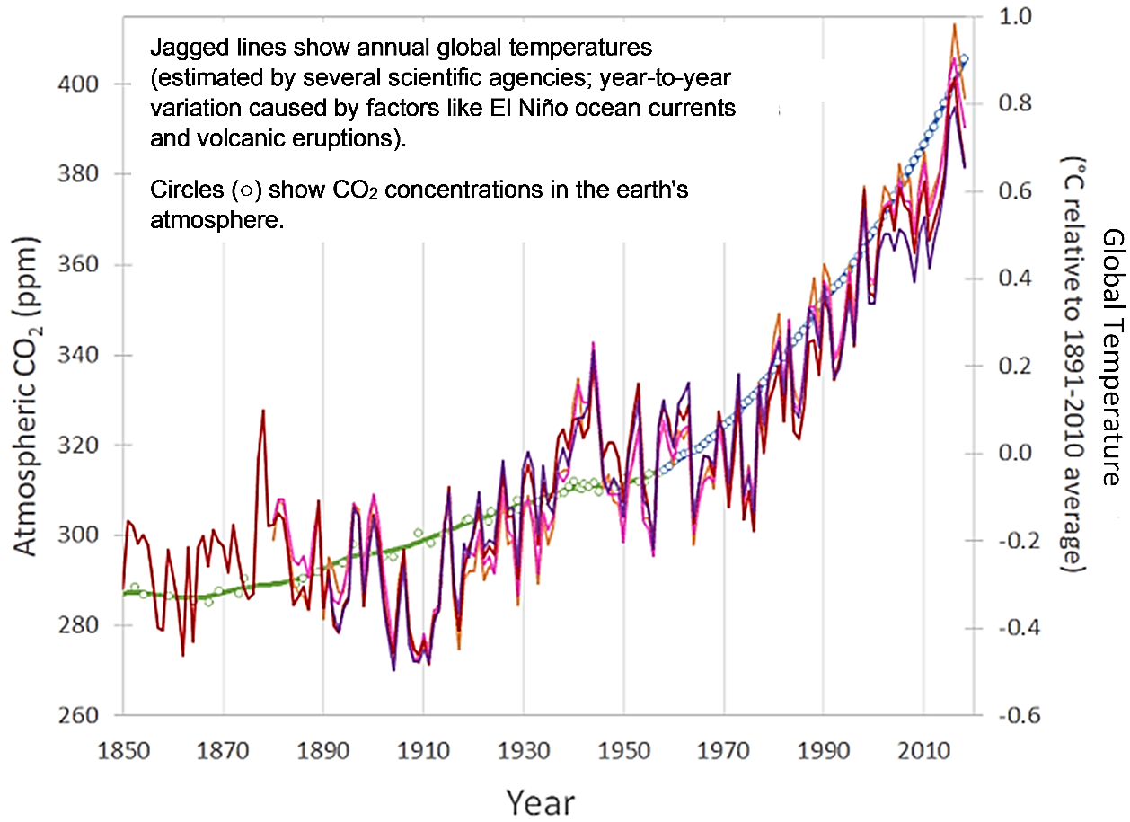

1a. What is global warming?

1b. Last winter, two weeks were unusually cold. Your friend said that this proved that there really isn’t any global warming. Do you agree ___ or disagree ___?

1c. Explain why.

2. For the last century, levels of CO₂ in the earth’s atmosphere have been higher than the maximum level during the previous 800,000 years. What do you think was the main cause of the increase in CO₂ levels in the atmosphere?

3a. During the last century, men’s average height and global temperatures both increased. Do these correlated trends mean that the increase in men’s height caused the increase in global temperature? yes ___ no ___

3b. Explain why or why not.

The figure on the previous page shows that the increase in levels of CO₂ in the atmosphere was correlated with an increase in global temperatures. However, correlation does not prove causation. Scientists have used several types of evidence to test the causal hypothesis that the increase in CO₂ in the atmosphere caused the increase in global temperatures.

First, scientists tested whether there is a mechanism that can explain how more CO₂ in the atmosphere could cause global warming.

4a. Laboratory experiments showed that, when CO₂ molecules absorb infrared radiation coming from one direction, then these CO₂ molecules emit infrared radiation in all directions. Read the labels in this figure, and then use the results of the laboratory experiments to complete label c.
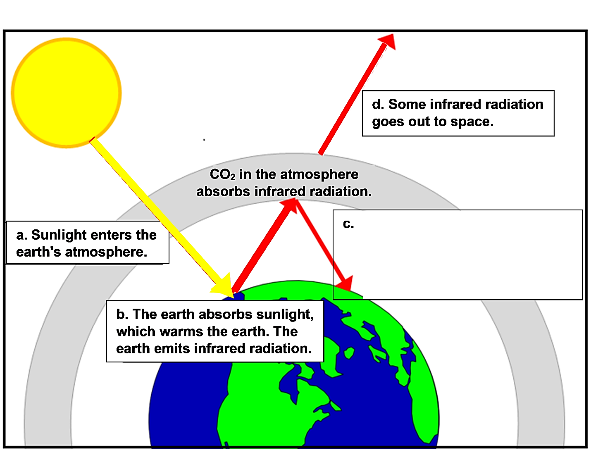

4b. When the amount of CO₂ in the earth’s atmosphere increases:
- the amount of infrared radiation that goes back to earth decreases ___ increases ___;
- the amount of infrared radiation that goes out to space decreases ___ increases ___.

4c. Explain how more CO₂ in the earth’s atmosphere causes an increase in global temperature.

5. Why is CO₂ called a greenhouse gas?

A second test of the causal hypothesis evaluates whether it can predict future temperature trends. Nineteenth century scientists predicted global warming, based on their understanding of the effects of CO₂ in the atmosphere. More recent models of the effects of CO₂ and other greenhouse gases have successfully predicted future temperature trends.

6. To test whether increases in CO₂ and other greenhouse gases have been the major cause of global warming, scientists have evaluated whether alternative hypotheses could account for the observed trends in global temperature. To see the results, view the animated graph, “How Global Warming Stacks Up” (https://climate.nasa.gov/climate_resources/144/). For each factor in the table below, indicate whether changes in this factor would be expected to result in the observed increase in global temperatures.
Possible Cause of Change in Global Temperature | Could this factor be responsible for the observed increase in global temperature?
Changes in the earth’s orbit | Yes ___ No ___
Changes in the temperature of the sun | Yes ___ No ___
Volcanic eruptions | Yes ___ No ___
Forest replaced with types of land-use that reflect more light | Yes ___ No ___
Changes in ozone in the upper and lower atmosphere | Yes ___ No ___
Aerosol pollution | Yes ___ No ___
Increase in greenhouse gases | Yes ___ No ___

7. Summarize the evidence that supports the hypothesis that increases in CO₂ and other greenhouse gases caused the increase in global temperature during the last century.

You may be wondering, “What’s all the fuss about a small increase in average temperature (only ~1.2°C or ~2.2°F thus far)?” Global warming and the resulting climate change have already caused harmful effects, including the following.
- Sea levels have risen because of the inflow of water from melting glaciers and because water expands as it warms. Rising sea levels have increased flooding in some coastal areas.
- Increased temperatures have increased evaporation from oceans and lakes, which has increased water vapor in the atmosphere. Increased intense rainfall has resulted in increased river flooding in some regions (e.g., in the northeastern US). In other regions, changes in wind patterns have resulted in decreased rainfall and more drought (e.g., in the southwestern US).
Scientists predict more serious problems as global warming continues. To avoid the worst effects, it will be important to limit global warming and the resulting climate change.

8. Suggest actions that you and other people could take to reduce fossil fuel use in order to limit global warming.

By Dr. Ingrid Waldron, Department of Biology, University of Pennsylvania. © 2022. The Student Handout and Teacher Notes with instructional suggestions and background information are available at https://serendipstudio.org/exchange/bioactivities/IntroGlobalWarming.

